BUG TRACKING SYSTEM
@CREATIVITY THINK (9483175986/7019689991)

ABSTRACT:
The Bug Tracking System is a dashboard-based web application that centralizes bug reporting, assignment, tracking, and analytics for software development teams. Users report bugs, update statuses, upload files, and collaborate using threaded comments, while administrators assign bugs, manage teams, and review analytical reports. Built with Django and Django Rest Framework on the backend and React with Redux and Chart.js on the frontend, the system ensures efficient workflow automation and real-time project visibility. Its structured approach improves productivity, accelerates debugging processes, enhances team collaboration, and maintains software reliability across development cycles..

INTRODUCTION OF THE PROJECT:
Modern software projects require organized bug tracking to ensure high-quality output and efficient team coordination. The Bug Tracking System resolves common issues such as scattered bug reports, unclear assignments, limited communication, and inadequate analytics. By integrating reporting, assignment, threaded discussions, progress tracking, and dashboards, the platform supports both developers and QA teams. The backend is powered by Django and DRF, while React with Redux provides a seamless front-end experience. This system enhances visibility, reduces delays, and supports data-driven decisions, making it essential for professional software development environments..

PROJECT OBJECTIVES:

• To provide a centralized platform for reporting software bugs
• To enable structured assignment of bugs to developers
• To support real-time status updates for each bug
• To allow threaded comments for collaborative debugging
• To generate analytics and visual dashboards for performance tracking
• To improve communication and workflow efficiency within development teams
• To reduce bug resolution time and enhance software reliability

PROBLEM OF THE STATEMENT:
Bug tracking is often disorganized across teams, leading to communication breakdowns, duplication of reports, undefined responsibilities, and delayed resolutions. Traditional manual tracking methods fail to provide structured workflows, real-time analytics, and team-specific dashboards. These limitations affect software quality and impact project timelines. A dedicated Bug Tracking System is required to centralize reporting, automate assignment, enable collaborative communication, maintain a history of actions, and analyze trends. This system ensures adherence to project timelines, systematic debugging, and improved team efficiency..

MOTIVATION OF THE PROJECT:
• To eliminate inefficiencies in traditional bug reporting methods
• To support collaborative debugging through threaded communication
• To provide analytics for decision-making and project monitoring
• To ensure transparent progress tracking for developers and QA teams
• To enhance software quality through systematic bug management

BLOCK DAIGRAM OF PROJECT:

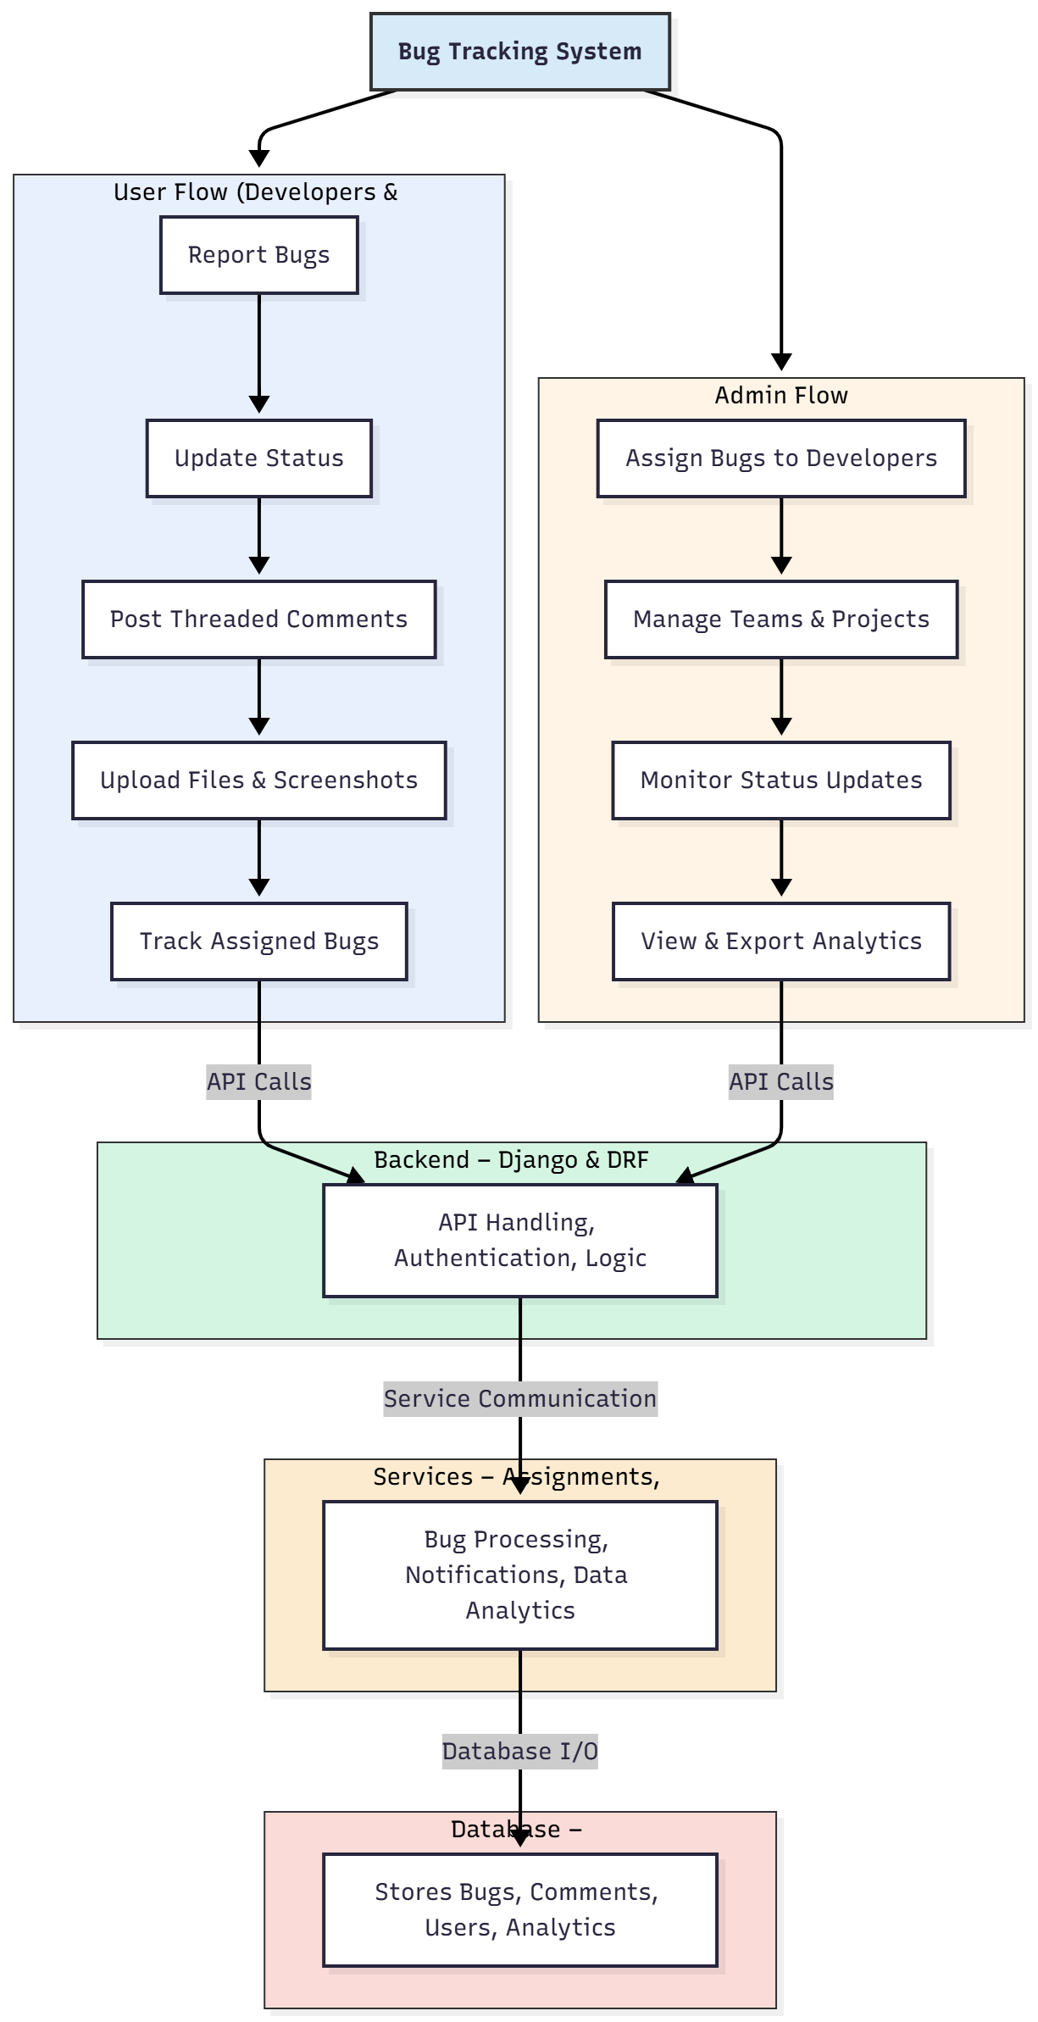

WORKING OF THE PROJECT:
The Bug Tracking System begins with users logging in and reporting bugs by entering details such as title, description, severity, and attachments. Developers and testers update bug statuses as they work on issues and communicate through threaded comments for easier debugging. The backend handles authentication, bug logic, and API communication, while services manage notifications, comment processing, and analytics generation. Administrators assign bugs to developers, oversee team activities, monitor project-wide progress, and export analytical reports. This integrated workflow ensures transparency, faster debugging, improved collaboration, and reliable software delivery..

SOFTWARE REQUIREMENT:
- Backend:
  - Python 3.x
  - Django
  - Django REST Framework
  - SQLite/PostgreSQL
- Frontend:
  - Node.js and npm
  - React.js
  - Axios
- Development Tools:
  - Visual Studio Code
  - Postman (for testing APIs)
  - Git/GitHub (for version control)
- Server/Deployment (Optional):
  - Gunicorn, Nginx, or Heroku/AWS for hosting

ADVANTAGES OF THE PROJECT:

• Centralized management of all bug reports
• Real-time updates for faster resolution
• Threaded comments for efficient communication
• Visual dashboards for bug analytics and trends
• Improves coordination between QA and development teams
• Enhances software reliability and code quality
• Provides transparency in project progress
• Reduces delays caused by miscommunication

APPLICATIONS OF THE PROJECT:
• Software development companies
• Quality assurance teams
• IT support and maintenance teams
• Agile and Scrum-based development environments
• Freelance and agency software projects
• University and institutional software labs
• Enterprise-level development workflows
• Any organization needing structured bug tracking

REFERENCES:

- Django REST Framework Documentation — Django Software Foundation. Django Documentation. Available: https://docs.djangoproject.com/
- Django REST Framework. DRF Documentation. Available: https://www.django-rest-framework.org/
- React. React Official Documentation. Available: https://reactjs.org/docs/getting-started.html
- Redux. Redux Documentation. Available: https://redux.js.org/introduction/getting-started
- PostgreSQL Global Development Group. PostgreSQL Documentation. Available: https://www.postgresql.org/docs/
- MySQL. MySQL Reference Manual. Available: https://dev.mysql.com/doc/
- Git. Git Documentation. Available: https://git-scm.com/doc
- Node.js. Node.js Documentation. Available: https://nodejs.org/en/docs/
- Axios. Axios Documentation. Available: https://axios-http.com/docs/intro
- Socket.io Documentation – https://socket.io/docs/

